|  |  |  |  |  |
| --- | --- | --- | --- | --- |
| Visual Arts  Reinventing objects | | Unit 5 | | |
| Assessment task — Collection of work | | | | |
| Name |  | | Class |  |
| Teacher |  | | Date |  |

Task

To explore ideas about recycling and the environment through found object sculpture.

Instructions

Part A: Responding

Respond to artworks and identify where and why artworks are made and presented.

Share ideas about recycling and the environment with an audience.

Part B: Making

Create artworks from reinvented objects.

Select and display artworks.

Conditions

Undertaken individually

To be completed in a number of supervised sessions

Stimulus material provided prior to assessment

Responding tasks — written or scribed

There are no recommended times or lengths in Years P–2 Band.

Note: Aboriginal peoples and Torres Strait Islander peoples are warned that this resource may contain images, voices and names of persons who may now be deceased.

Task 1: Looking at artworks

Part A: Responding

Respond to artworks and identify where and why artworks are made and presented.

Look closely at the artwork *Spectra of birds* by Madeleine Kelly to answer the questions.

|  |  |  |  |  |  |  |  |  |
| --- | --- | --- | --- | --- | --- | --- | --- | --- |
| G:\8047_C2C\The Arts\_Visual Arts\Prep -Yr 2\Prep-Yr 2_Unit 5\Writ1ng\Sign-off\Level 2\Assessment\images\VAR_YP-02Band_U5_MKellySpectra.tif  Madeleine Kelly, Germany/Australia b.1977, *Spectra of birds* 2014-15, Encaustic on cardboard with paper and text 40 parts ranging from 8 x 11 x 11cm to 27 x 9 x 9cm; installed dimensions variable; Purchased 2015 with funds from the Josephine Ulrick and Win Schubert Diversity Foundation through the Queensland Art Gallery | Gallery of Modern Art Foundation, Collection: Queensland Art Gallery, © Madeleine Teresa Kelly 2014–15 / Licensed by Viscopy, Sydney, 2015; Photograph: Natasha Harth, QAGOMA; Image courtesy: Queensland Art Gallery | Gallery of Modern Art | | | | | | Madeleine Kelly  *Spectra of birds*, 2014  G:\8047_C2C\The Arts\_Visual Arts\Prep -Yr 2\Prep-Yr 2_Unit 5\Writ1ng\Sign-off\Level 2\Assessment\images\VAR_YP-02Band_U5_MKellySpectraDetail.tif  Madeleine Kelly, Germany/Australia b.1977, Spectra of birds (detail) | | |
| What do you see in this artwork? | | | | | | | | |
| Which shape do these birds remind you of? | | | | | | | | |
|  | |  | |  | | |  | |
| How was this artwork made? Circle the materials and techniques that were used. | | | | | | | | |
| G:\8047_C2C\The Arts\Avatars\Visual_Arts_Leo_Raku\VAR_avatar_Leo_paintbrushes_easel.png  paint | G:\8047_C2C\The Arts\Avatars\Visual_Arts_Leo_Raku\VAR_avatar_Raku_ scissors_glue.png  collage | | G:\8047_C2C\The Arts\Avatars\Visual_Arts_Leo_Raku\VAR_avatar_Leo_making.png  sculpture | | G:\8047_C2C\The Arts\Avatars\Visual_Arts_Leo_Raku\Var_Raku_crayon.png  crayon | | | G:\8047_C2C\The Arts\Avatars\Visual_Arts_Leo_Raku\VAR_avatar_Leo_pencils.png  pencils |
| What are the birds made of? | | | | | | | | |
| Why did the artist make an artwork about birds? Think about recycling materials and our environment. | | | | | | | | |

Task 2: Make a sculpture of a bird

Part B: Making

Create artworks from reinvented objects.

Make a sculpture of a bird by recycling found objects and materials.

Look at artworks by different artists to inspire your work,

e.g. Spectra of birds by Madeleine Kelly

Mourning chorus by Fiona Hall

Tjulpu (Bird) by Tjunkaya Tapaya

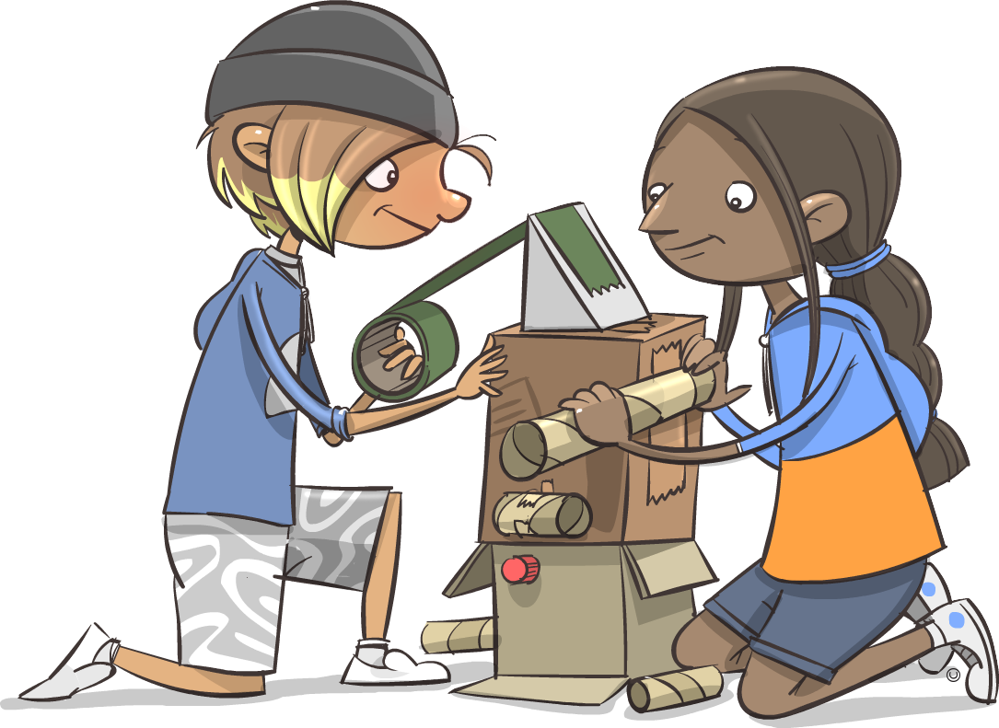

Task 3: Display your artwork

Part B: Making

Select and display artworks.

Share ideas about found objects with an audience:

* 1. Give your artwork a title.
  2. Present your artwork for display to your class. You can display a photo of it below if you   
     need to.

|  |
| --- |
| Artwork title: |

Task 4: Talk about your bird

Part A: Responding

Respond to artworks and identify where and why artworks are made and presented.

Think about the bird sculpture you made.

Tell your teacher and class about it.

* What’s the name of your bird?
* How did you make it?
* Where does it live?
* What does it eat?
* What is the bird’s life like?



You could write about the colours, shapes and patterns you used in your bird.

|  |
| --- |
|  |

**Visual Arts –– Reinventing objects**

**Student Name: \_\_\_\_\_\_\_\_\_\_\_\_\_\_\_\_\_\_\_\_\_\_\_\_ Date: \_\_\_\_\_\_\_\_\_\_\_\_\_\_\_\_\_\_ Teacher: \_\_\_\_\_\_\_\_\_\_\_\_\_\_\_\_\_\_\_\_\_\_\_\_\_**

**Purpose of assessment: To explore ideas about recycling and the environment through found object sculpture.**

|  |  |  |  |  |  |  |
| --- | --- | --- | --- | --- | --- | --- |
| **Content Descriptors** | | **Very High** | **High** | **Sound** | **Developing** | **Support required** |
| **Responding** | *Describes artworks they make and view and where and why artworks are made and presented.* | Describes artworks, in detail, and explains ideas;   * Describes, in detail, artworks made and viewed * Describes, in detail, where and why artworks are made and presented * Identifies ideas about recycling and the environment in own and others’ artworks made with found objects and materials * Explains how visual language such as colour, shape and pattern in artists’ works represent imaginative ideas about recycling in the environment. | Describes artworks, in detail, and identifies ideas;   * Describes, in detail, artworks made and viewed * Describes, in detail, where and why artworks are made and presented * Identifies ideas about recycling and the environment in own and others’ artworks made with found objects and materials. | Describes artworks;   * Describes artworks made and viewed * Describes where and why artworks are made and presented. | Discusses artworks;   * Discusses own and others’ artworks. | Makes statements about own artwork;   * States observations about own artwork. |
| **Making** | *Makes artworks in different forms to express ideas, observations and imagination, using different techniques and processes.* | Skilfully and effectively makes artworks in different forms to express and communicate ideas, observations and imagination, using different techniques and processes;   * Skilfully and effectively makes artworks in different forms to express ideas, observations and imagination, using different relevant techniques and processes * Uses inspiration from artworks they view to inspire their own representations without replicating other artists’ works * Communicates expressive and imaginative ideas about the environment through the use of found objects. | Effectively makes artworks in different forms to express ideas, observations and imagination, using different techniques and processes;   * Effectively makes artworks in different forms to express ideas, observations and imagination, using different relevant techniques and processes * Uses inspiration from artworks they view to inspire their own representations without replicating other artists’ works. | Makes artworks in different forms;   * Makes artworks in different forms to express ideas, observations and imagination, using different techniques and processes. | Makes artworks;   * Uses techniques and processes to make artworks. | Makes fragmented artworks;   * Uses materials to make artworks. |
| **Teacher Comment:** | | | | | | |