The Arts  On the cover |  | Year 4
Assessment task — Collection of work
Name |  |  | Class
Teacher |  |  | Date

Task
To explore media artworks that inform the making of an electronic magazine cover that appeals to a target audience.
Instructions
Part A: Responding
Describe and discuss the use of images and text in a magazine cover.
Reflect on how your electronic magazine cover appeals to a target audience.
Part B: Making
Plan and design (pre-production) — Plan and design an electronic magazine cover that appeals to a target audience.
Production — Make and share an electronic magazine cover that appeals to a target audience.
Conditions
- Undertaken individually
- Length — Written response 30–200 words

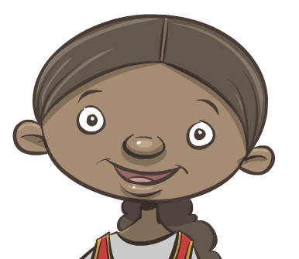
Task 1: Magazine cover discussion
Look carefully at everything on the cover.
Part A: Responding
Describe and discuss the use of images and text in a magazine cover.
Choose a magazine cover that features people. Answer the following questions about the cover.
Note: This may be done orally if recorded to send to your teacher.
- Choose two features on the magazine cover.
 | costumes |  | props |  | setting | colour
- Describe the two features you have chosen.
- Discuss how these features appeal to the target audience.
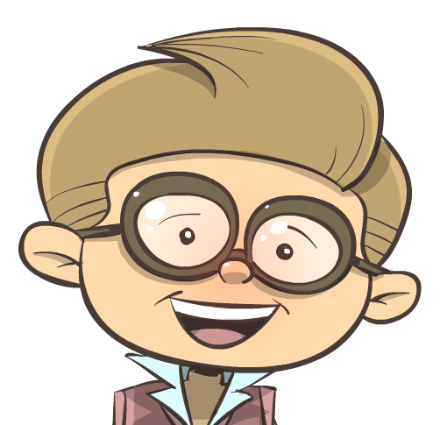
Think about costumes, props, setting and colour.
Task 2: Magazine cover plan
GTMJ ‘C’, ‘B’ and ‘A’ descriptors with evidence from model response.

Describes and discusses similarities and differences between media artworks they view. (C)

Discusses how and why others use image and text to make and present media artworks. (C)

Identifies how costume, prop, setting and colour are used to characterise people in images. (B)

Explains how image and text have been used to appeal to a target audience in magazine covers. (A)
Part B: Making
Plan and design (pre-production) — Plan and design an electronic magazine cover that appeals to a target audience.
- Design: Plan and design a new magazine cover that appeals to a target audience using image, text and the characterisation of people.
- Image: Plan photograph/s for the headline image and/or cover line image/s.
- Sound: Write scripts for the headline and all cover line voice-overs.
Note: This may be done orally if recorded and sent to your teacher.
- Draw and write down ideas for the images that will match the headline and/or cover lines.
Target audience: _____________________________________________
Image: |  |  |  | people
 |  |  |  | costumes
 |  |  |  | props
 |  |  |  | setting
 |  |  |  | colour scheme
 |  |  |  | voice-overs
- Page design
Lay out the features of the magazine cover around the headline image.
Voice-overs will be a sound feature on your cover.
Task 3: Making an electronic magazine cover
Part B: Making
Production — Make and share an electronic magazine cover that appeals to a target audience.
Make an electronic magazine cover using:
- image, sound and text
- characterisation of people in photographs to match the headline and/or cover lines
- purposeful design choices that will appeal to the magazine’s target audience
- ICT equipment and software to capture and edit image and sound.
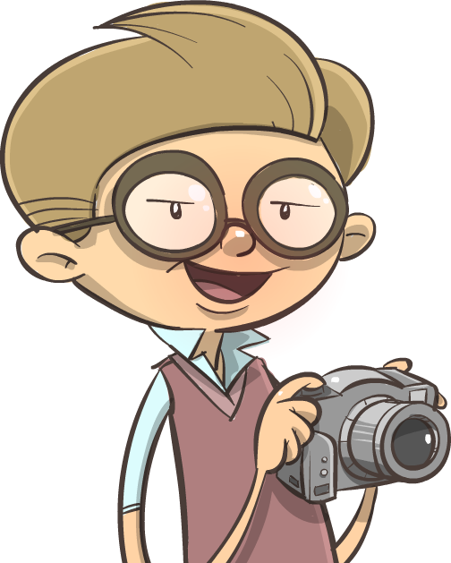
Share your finished electronic magazine cover with an audience.
Task 4: Reflection
Part A: Responding
Reflect on how your electronic magazine cover appeals to a target audience.
Explain why your design (image, sound and text) appeals to a target audience.
Note: This may be done orally if recorded
Explain your thoughtful design choices.
and sent to your teacher.
 |  | How it appeals to target audience
Image
Sound
Text

Year 4 – Media Arts – Unit 3 – On the cover
Student Name: ________________________ Date: __________________ Teacher: _________________________

Purpose of assessment: To explore media artworks that inform the making of an electronic magazine cover that appeals to a target audience.
Content Descriptors |  | A | B | C | D | E
Making | Describes and discusses similarities and differences between media artworks they make and view. Discusses how and why they and others use images, sound and text to make and present media artworks.  Part A | Justifies features of media artworks;  - Explains, in detail, similarities and differences between media artworks they make and view  - Explains, in detail, how and why they and others use images, sound and text to make and present media artworks  - Describes how costumes, props, setting and colour are used to characterise people in images  - Explains how images, sound and text have been used to appeal to a target audience in media artworks. | Explains features of media artworks;  - Explains similarities and differences between media artworks they make and view  - Explains how and why they and others use images, sound and text to make and present media artworks  - Identifies how costumes, props, setting and colour are used to characterise people in images. | Describes features of media artworks;  - Describes and discusses similarities and differences between media artworks they make and view  - Discusses how and why they and others use images, sound and text to make and present media artworks. | Identifies some features of media artworks;  - Identifies images, sound and text used in media artworks. | Makes statements about media artworks;  - States ideas about media artworks.
Responding | Uses visual conventions, techniques and processes (i.e. story principles, time, space and technologies) to make and share media artworks that communicate ideas to an audience.  Part B | Effectively integrates and refines visual conventions to make and share media artworks to appeal to a target audience;  - Effectively integrates visual conventions, techniques and processes (i.e. story principles, time, space and technologies) to make and share media artworks that communicate ideas to an audience  - Effectively integrates costumes, props, setting, colour and the characterisation of people to appeal to a target audience when planning purposeful design choices for media artwork  - Refines the use of image, sound, text and technologies to make a cohesive media artwork that applies page layout design effectively. | Integrates visual conventions to make and share media artworks to appeal to a target audience;  - Integrates visual conventions, techniques and processes (i.e. story principles, time, space and technologies) to make and share media artworks that communicate ideas to an audience  - Integrates costumes, props, setting, colour and the characterisation of people to appeal to a target audience when planning purposeful design choices for media artwork. | Uses visual conventions to make and share media artworks;  - Uses visual conventions, techniques and processes (i.e. story principles, time, space and technologies) to make and share media artworks that communicate ideas to an audience. | Uses limited visual conventions to make media artworks;  - Uses time, space, story principles and technologies to make media artworks. | Uses a visual convention to make media artworks;  - Uses story principles to make media artworks.
Teacher Comment:

