Visual Arts  Grand shelter designs |  | Year 6
Assessment task — Collection of work
Name |  |  | Class
Teacher |  |  | Date

Task
Task: To use the design process to develop a concept drawing of a shelter for a particular site and purpose.
Instructions
Part A: Responding
Respond to work by designers and explain how ideas are represented in shelter designs.
Present — Pitch design ideas to an audience.
Part B: Making
Plan — Develop and draw a shelter for use in the school environment.
Design — Draw a concept design for a shelter based on a design brief.
Conditions
- Undertaken individually
- Stimulus material provided prior to assessment
- Responding tasks: 50–300 words
- Design pitch: 2–3 minutes

Part A: Responding
Respond to work by designers and explain how ideas are represented in shelter designs.
Task 1: Research designs.
Explain how form and function are incorporated in a shelter design.
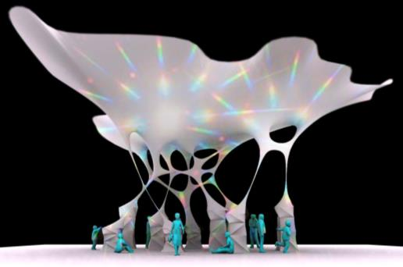 | Chris Bosse  Cloud City  2013  Chris Bosse LAVA Cloud City: an urban ecosystem installation, 2013.  Courtesy of the designer. Image © Brett Boardman Photography.
Chris Bosse is a designer who is interested in buildings for the future. He believes that buildings should be able to change to suit the environment, and not be rigid or unchanging like most buildings from the past.
- What do you think is the purpose of Cloud City?
- Explain how form and function have been used in this design.
- What is the shelter made from?

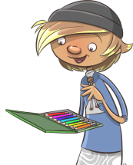
Part B: Making
Plan — Develop and draw a shelter for use in the school environment.
Task 2: Design brief
Use the sheet Design process: Student workbook to develop a design brief
that explains the site and purpose for a shelter in the school environment.

Site  Include a photograph or  drawn image of the site. | Users | Function of shelter
How do you plan to incorporate the elements and principles of design in your shelter?
Choose one element or principle of design from the list below and explain how you have used it.
Elements and principles of design
Colour

Line

Shape/Form

Texture

Scale

Contrast

Proportion

Part B: Making
Design — Draw a concept design for a shelter based on a design brief.
Task 3: Draw and label your design here (show the main features of your design).
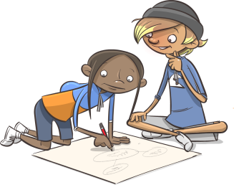

Part A: Responding
Present — Pitch design ideas to an audience.
Part B: Making
Design — Draw a concept design for a shelter based on a design brief.
Task 4: Design pitch
Describe and explain your design to other students in the class as a video and send this to your teacher.
Persuade other students that your shelter will be an important addition to the school environment.

Share your design with them.
Your presentation can include:
What have you included in your design and why have you included it?
- the purpose of your design
- a description of the site for your shelter
- your influences
- your final concept design.

Year 6 – Visual Arts – Unit 3 – Grand shelter designs
Student Name: ________________________ Date: __________________ Teacher: _________________________

Purpose of assessment: To use the design process to develop a concept drawing of a shelter for a particular site and purpose.
Content Descriptors |  | A | B | C | D | E
Responding | Explains how ideas are represented in artworks they make and view. Describes the influences of artworks and practices from different cultures, times and places in their art making. Describes how the display of artworks enhances meaning for an audience.  Part A | Elaborates and justifies ideas about artworks and how they are displayed;  - Justifies how ideas are represented in artworks they make and view  - Elaborates how designers incorporate form and function in a range of shelter designs  - Explains, in detail, the influences of artworks and practices from different cultures, times and places in their art making  - Explains, in detail how the display of artworks enhances meaning for an audience  - Presents a persuasive pitch to communicate how and why the concept shelter design responds to the design brief. | Elaborates on ideas about artworks and how they are displayed;  - Explains, in detail, how ideas are represented in artworks they make and view  - Discusses how designers incorporate form and function in a range of shelter designs  - Explains the influences of artworks and practices from different cultures, times and places in their art making  - Explains how the display of artworks enhances meaning for an audience. | Explains ideas about artworks and how they are displayed;  - Explains how ideas are represented in artworks they make and view  - Describes the influences of artworks and practices from different cultures, times and places in their art making  - Describes how the display of artworks enhances meaning for an audience. | Describes ideas about artworks and how they are displayed;  - Describes ideas in designs made and viewed. | Makes statements about artworks and how they are displayed;  - States ideas about design.
Making | Uses visual conventions and visual arts practices to express a personal view in artworks. Demonstrates different techniques and processes in planning and making artwork.  Part B | Demonstrates effective skills and techniques when making an artwork;  - Uses appropriate materials effectively to create an artwork  - Uses visual conventions and visual arts practices to express individualised ideas in design  - Applies influences from artists, designers and the environment in planning and designing a shelter that meets their own design brief  - Demonstrates effective techniques and processes in planning and making artwork  - Develops and illustrates an innovative concept design that combines form and function for a specific site. | Demonstrates proficient skills and techniques when making an artwork;  - Uses appropriate materials proficiently to create an artwork  - Uses visual conventions and visual arts practices to express individualised ideas in design  - Applies influences from artists, designers and the environment in planning and designing a shelter that meets their own design brief  - Demonstrates proficient techniques and processes in planning and making artwork. | Demonstrates skills and different techniques when making an artwork;  - Uses appropriate materials to create an artwork  - Uses visual conventions and visual arts practices to express individualised ideas in design  - Demonstrates different techniques and processes in planning and making artwork. | Demonstrates limited skills and techniques when making an artwork;  - Uses materials to create an artwork  - Uses visual conventions and visual arts practices  - Demonstrates techniques and processes in making artwork. | Demonstrates fragmented skills and techniques when making an artwork;  - Uses materials to create an artwork.
Teacher Comment:

